University of Central Punjab
Faculty of Information Technology and Computer Science

Course Title: Software Construction & Development
Course Code: SESD3242

Assignment 3

Name | ID | Contribution in the assignment (Specifically mention the part which you have done)
Laheem Ayub | L1F23BSSE0176 | Components: Student Name, Roll No, Book Title  Exceptions: EmptyFieldException, InvalidRollNumberException
Muhammad Umar | L1F23BSSE0137 | Components: Book Category, Book Type, Issue Date, Return Date  Exceptions:NullSelectionException, InvalidDateException

CLO | At the end of the course the students will be able to: | BT Level* | PLO
CLO2 | Apply construction techniques to write a clean and maintainable code that meets industry standards and best practices. | C2 | 2

Deadline: 24-May-26 Total Marks= 50

Instructions:
- Late submission will cause 20% deduction. No submission after 2 Days.
- This assignment is a group assignment. 2 members in each group. Individual submissions will not be accepted.
- ASSIGNMENT SHOULD BE PROPERLY TYPED.
- Attach this title page to your submission. (5 marks)
- Upload it on the portal on 24-May-26_at 11:55pm
- Plagiarism is seriously your own choice.
- Evaluation will be viva-based. Viva date and time will be announced later.

GitHub Repository Link
We managed our project code source using Git. Below is our active public repository URL:
https://github.com/M-Laheem-Ayub/smart-library-system

List of Implemented Exceptions
We added 5 exceptions and a final block inside the backend to prevent crashes and display messages using JOptionPane.
1. EmptyFieldException (Custom)
Triggers when Student Name, Roll Number, or Book Title is left blank or empty.
2. InvalidRollNumberException (Custom)
Triggers if the entered Roll Number includes letters or has an invalid pattern length.
3. NullSelectionException (Custom)
Triggers when no Book Type (New or Old Edition radio button) is selected by the user.
4. InvalidDateException (Custom)
Triggers when the Return Date comes before the Issue Date, or has a wrong text pattern format.
5. NumberFormatException (Built-in)
Triggers automatically by Java when text inside the Roll Number field fails to parse as a valid number.
6. Finally Block (Mandatory Cleanup)
Always runs at the end to show an unconditional 'Operation Completed' status message window.

Screen Output Placeholders
==================================================
[ OUTPUT 1: ORIGINAL BLANK FORM ]
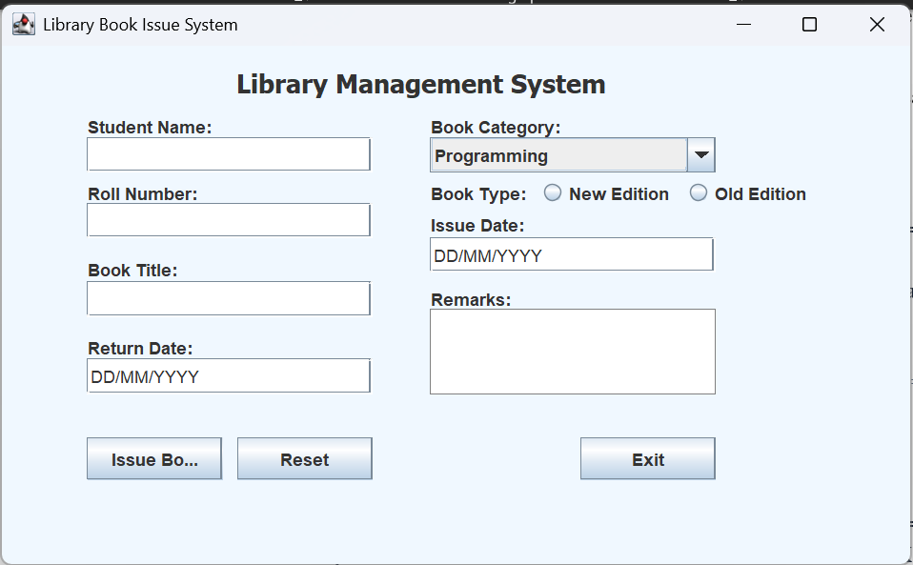
==================================================
==================================================
[ OUTPUT 2: EMPTY FIELD EXCEPTION BOX ]
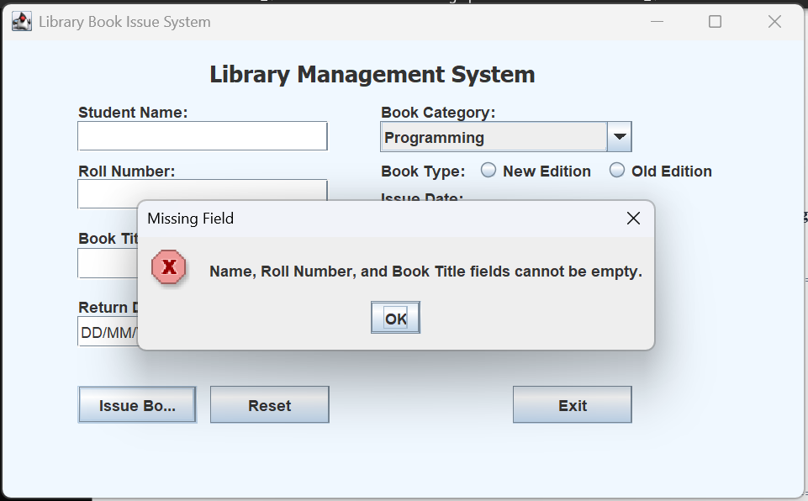
==================================================
==================================================
[ OUTPUT 3: INVALID ROLL NUMBER BOX ]
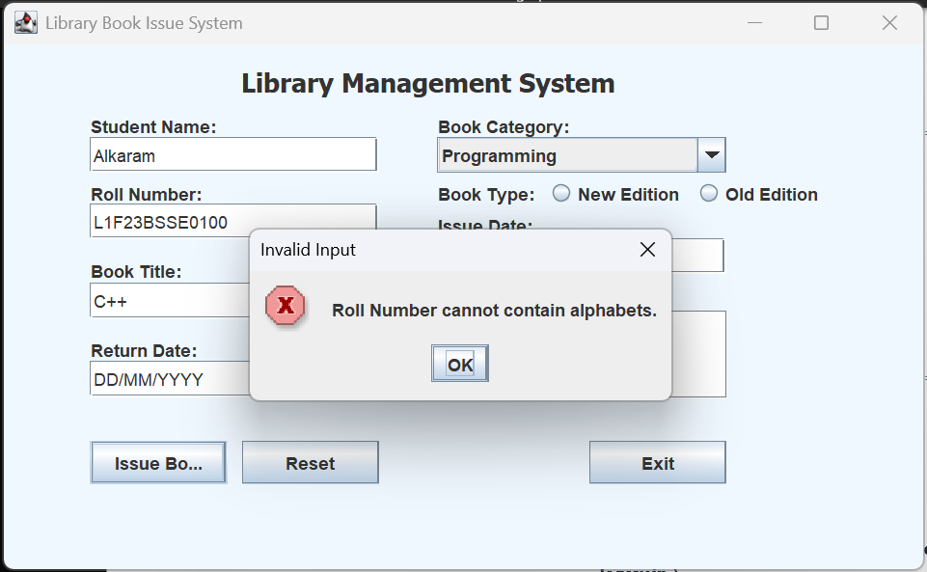
==================================================

==================================================
[ OUTPUT 4: INVALID DATE EXCEPTION BOX ]
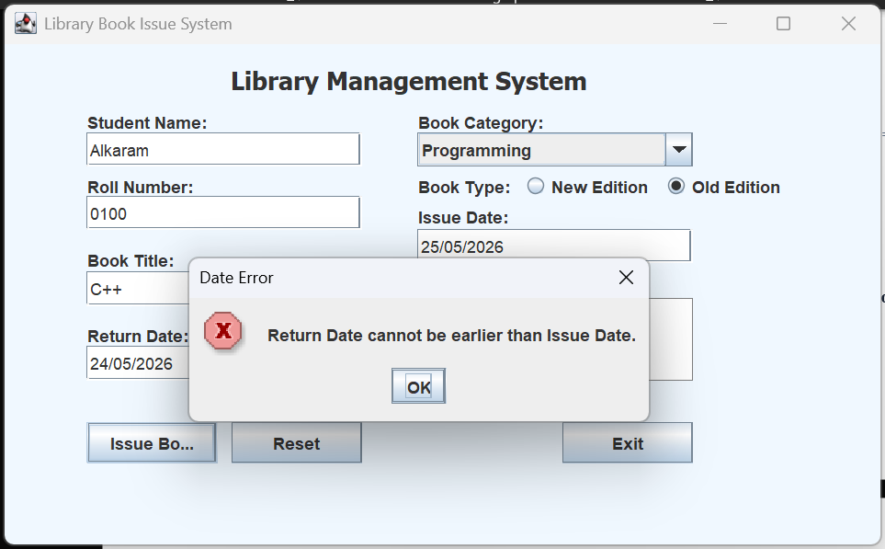
==================================================
==================================================
[ OUTPUT 5: SUCCESS DIALOG BOX ]
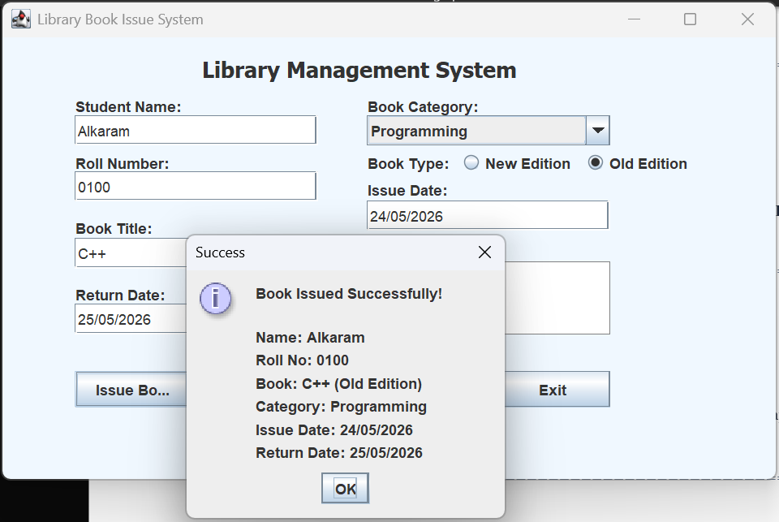
==================================================

==================================================
[ OUTPUT 6: FINALLY BLOCK COMPLETION BOX ]



